Date: 10-11-2025

User Manual


Green Concrete Employee Mobile App
The App is built for company employees to simplify daily operations. Employees can:
- Mark their Attendance, Submit HR requests and Breakdown reports, View today’s orders, Track and update each order’s status—from truck dispatch to customer acceptance or rejection

Features

- Login

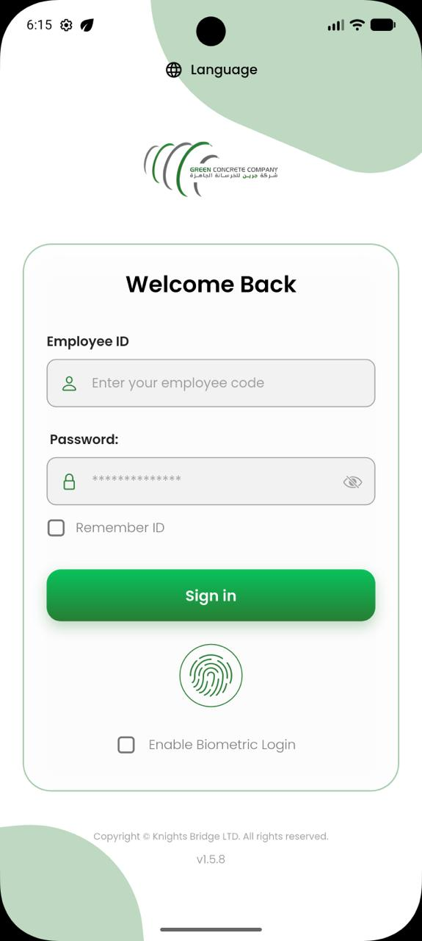
- Users can log in to the app using their Employee Code and the corresponding password assigned to them.
- Login sessions are stored in the database to enable quick and seamless access with fingerprint or face recognition.

- Change Language

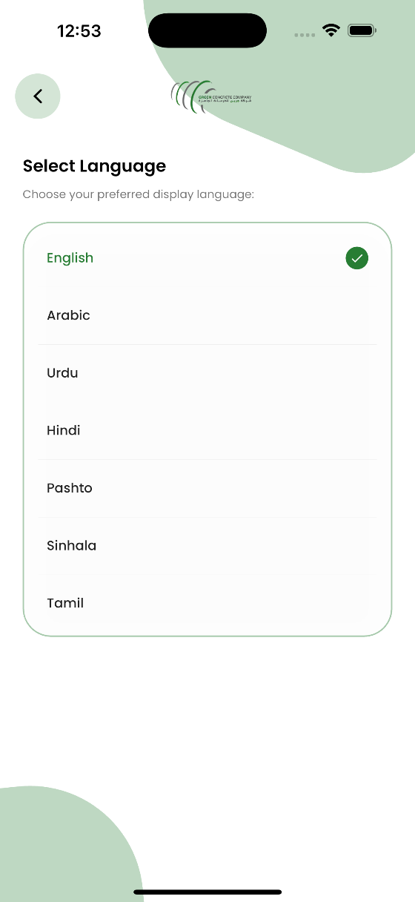
- User can change the language for the app by clicking on flag icons on the top right side.

- Dashboard (Driver & Employee)

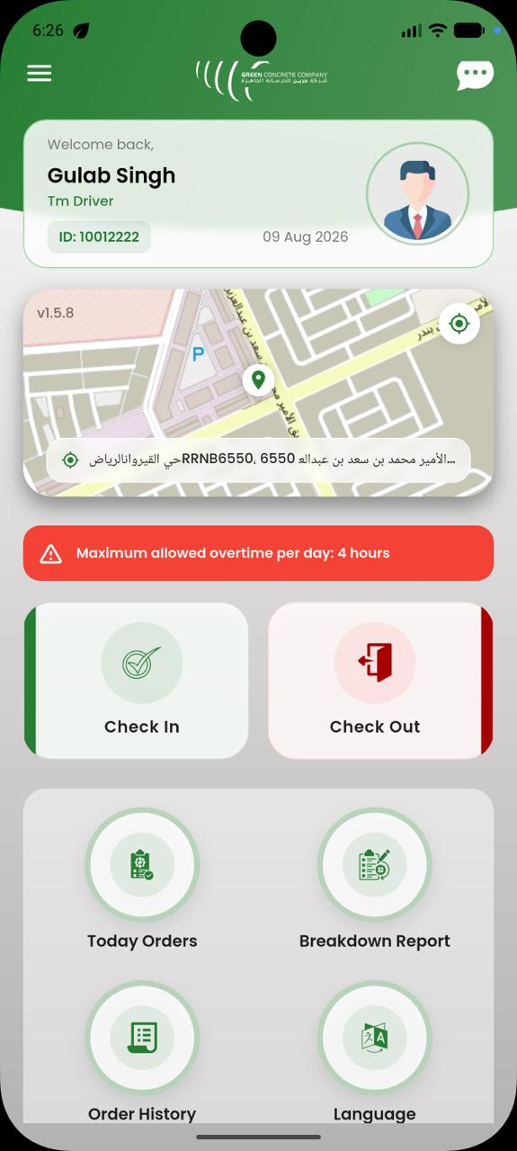
- Users can check in on morning/evening shift and can also check out.
- The current location of the user is saved in the backend during check-in and check-out.
- All options are accessible directly from the app dashboard for easy use.

- User Profile

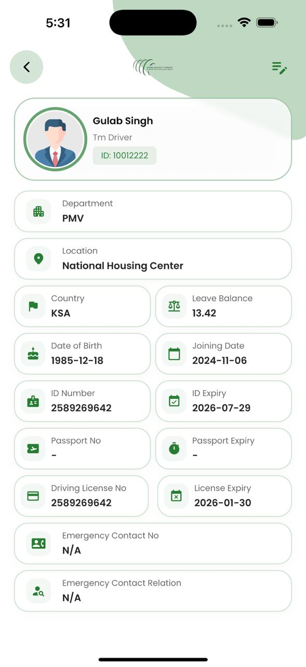
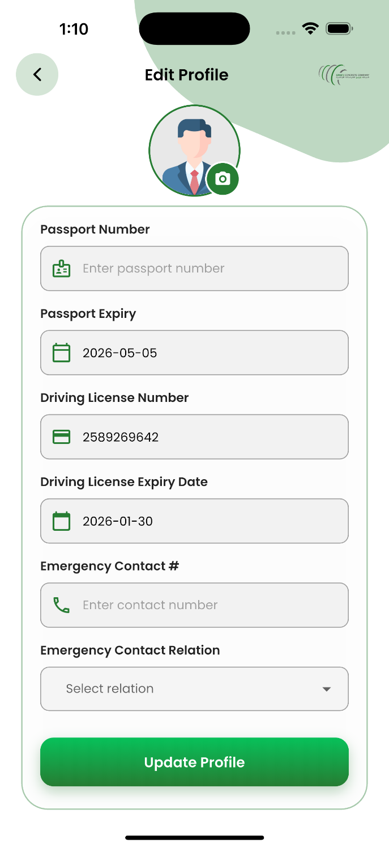
- The app includes a user profile where drivers can view and edit their personal information and account details.

- Employee In App Chat
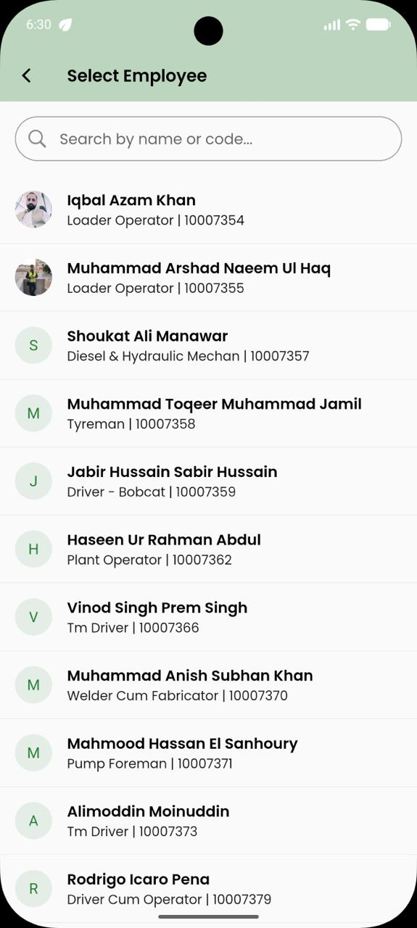
- User can do business chats with his department employees.
- User can send messages, pictures, videos, audios.

- Dispatch Today Orders
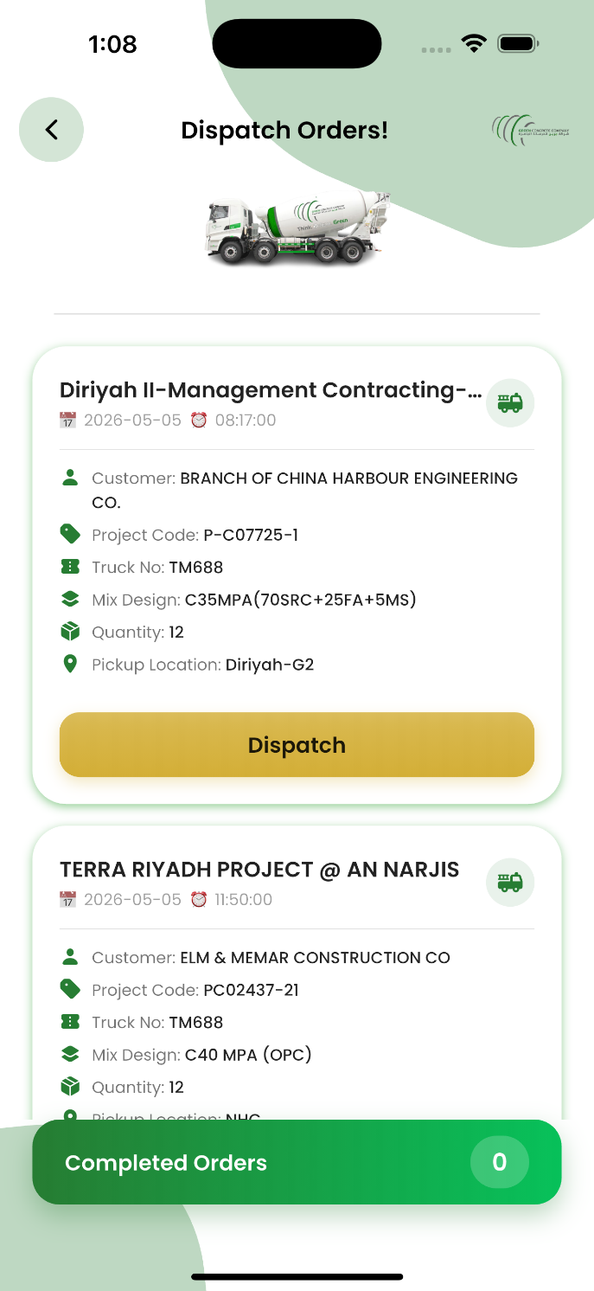
- This page on the app shows all today orders which are already loaded for current shift.
- For each order, driver can check project details, location, pickup details and truck details.
- He can select Dispatch to start the order.

- Order Tracking

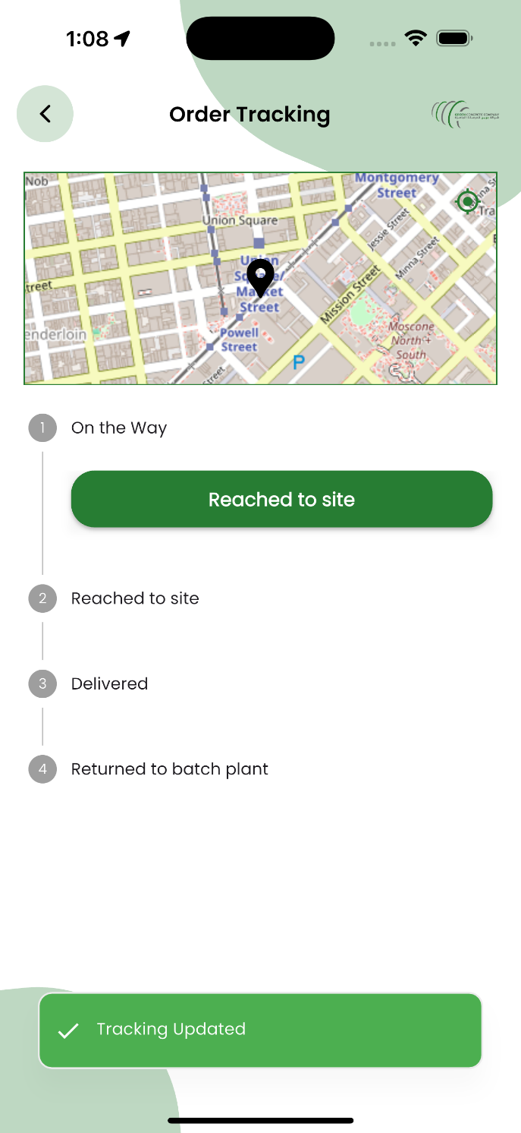
- Now the order status is on the way and the location will updated after every 5 min
- Once he reaches to the site, he will mark Reached to Site from this order tracking page.

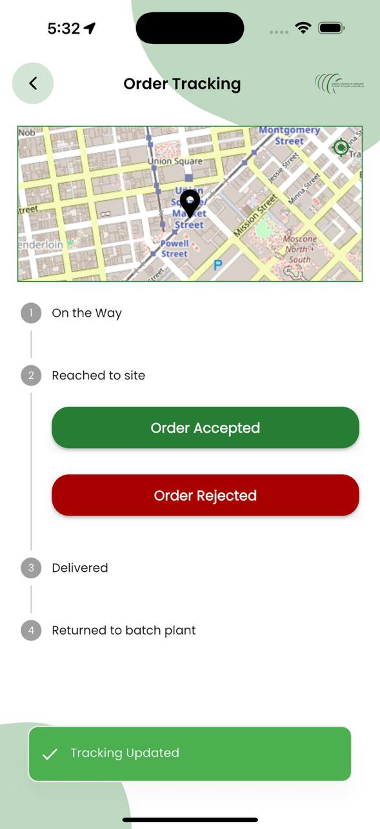
- When a driver reaches on the site, he will have 2 options to select from.
Order Accepted or Order Rejected
- Driver will have to select from the given options to proceed with the next step.

- Accepted Orders

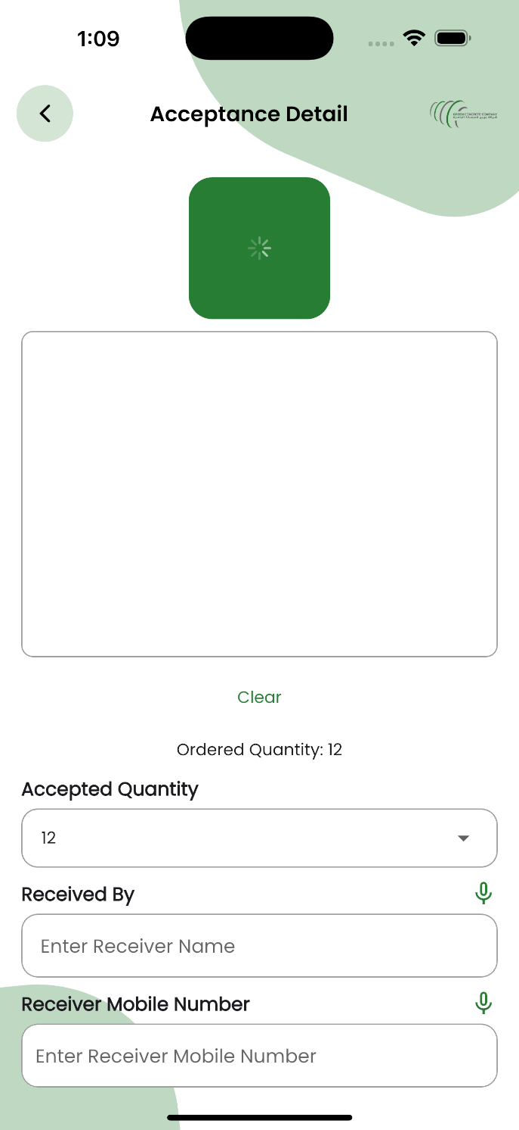
- To complete an accepted order, driver will take signature of the customer who accepted the order.
- Once signature is taken, it will automatically take picture of the customer who signed.
- Driver can select accepted quantity from drop down and mark exact amount accepted.
- Driver will add information for order: Received by, Mobile number and remarks. He can add audio input for the remarks as well which will be reflected on the remarks text box.
- After adding all the information, driver will submit the order as accepted.
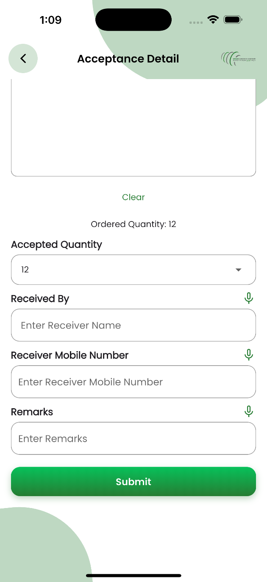

- Rejected Orders

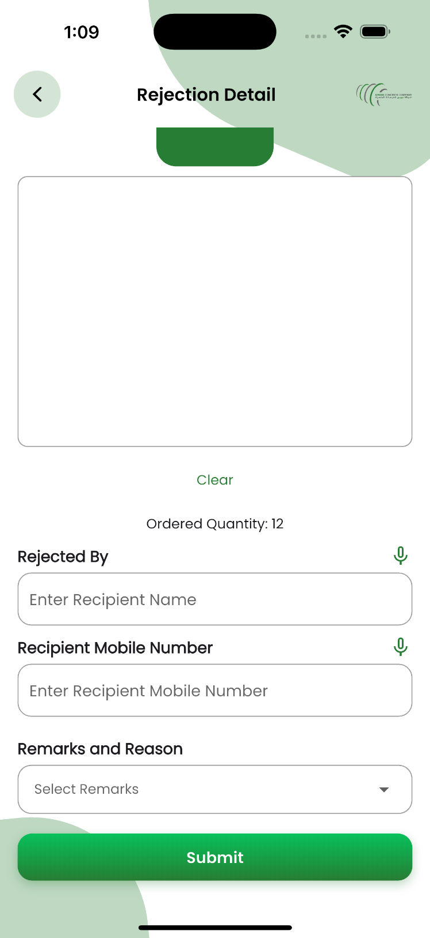
- To reject an order, driver will take signature of the customer who rejected the order.
- Once signature is taken, it will automatically take picture of the customer who signed.
- Driver will add information for order: rejected by, Mobile number and remarks. He can add audio input for the remarks as well which will be reflected on the remarks text box.
- After adding all the information, driver will submit the order as rejected.

- Delivery Docket

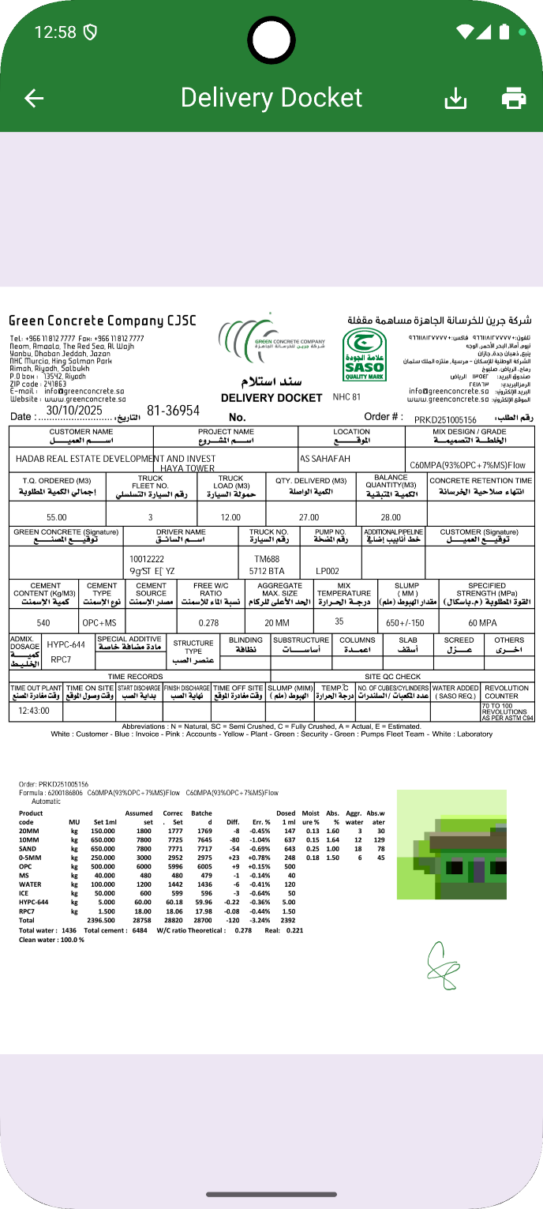
- When the order is marked as accepted, the delivery docket will be displayed on the screen with additional information like picture of customer and customer signature.
- Driver can share or print this updated docket at the time of delivery.
- This docket will automatically be saved in the database for further analysis or processing.

- Orders History

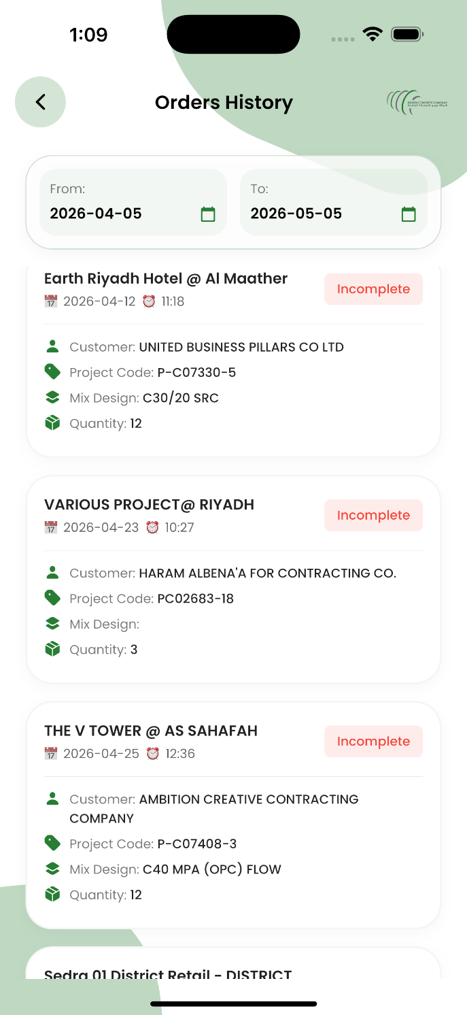
- Driver can check his order history from the app.
- He can check completed or incomplete orders. Completed orders will have a docket in the attachment to view.
- Driver can check his past orders from the filters added on the top of screen.

- Breakdown Reports

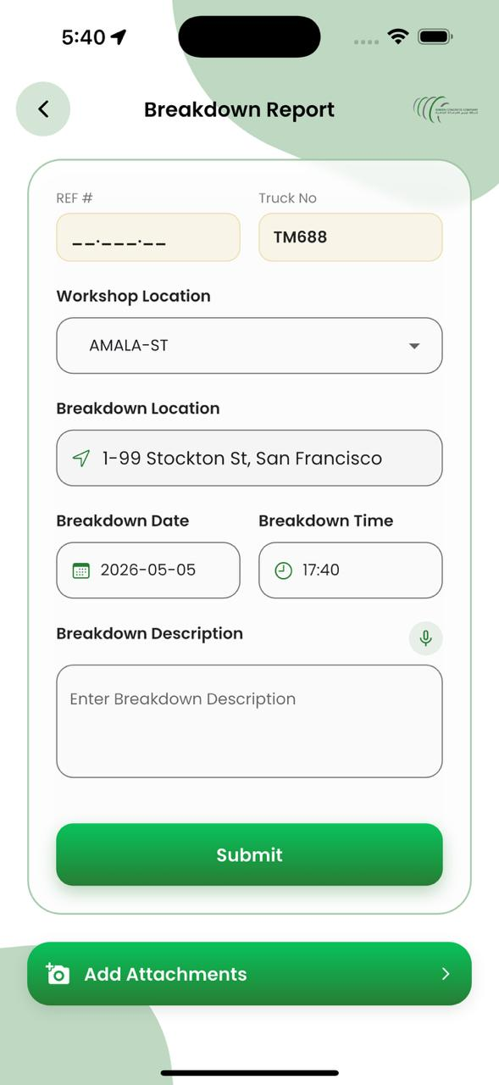
- Driver can add incident reports on the app.
- This page will automatically fetch user information like: Location of driver, date, time, driver details.
- Driver will select incident types or he can just voice type in incident description (If any word will match in Incident Types then it will be selected automatically)
- After filling the information, driver will add an attachment for the incident report and when submitted this data will be stored and used for further processing.

- RFR Request

After submission of breakdown report, a request will be generated to RFR Command Centre to take the action accordingly to open the Job Card.

- HR Requests

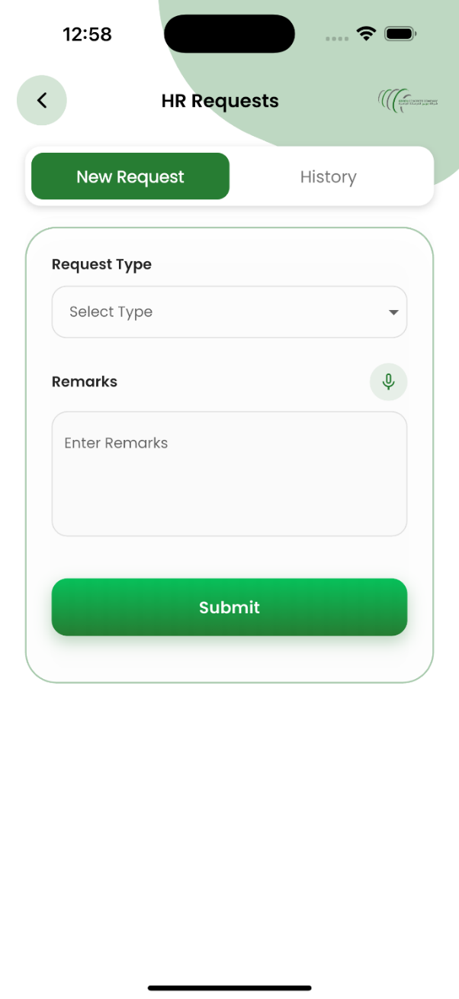
- Employee can add request to HR.
- He can request for leave, uniform or Salary Certificate.
- Once request type is selected, employee will add further remarks and submit this request.

- Timesheet

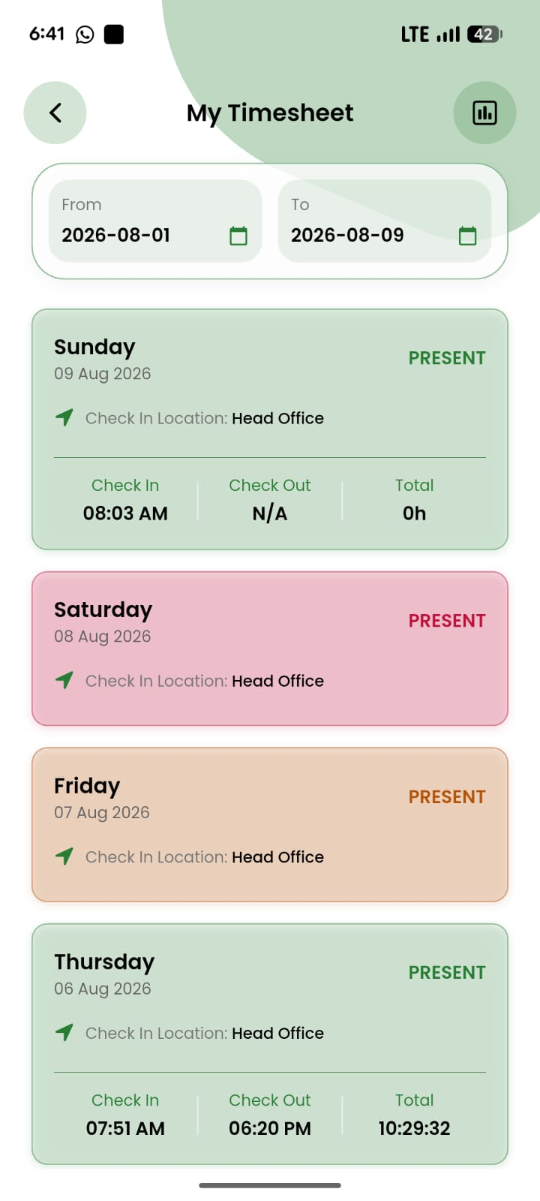
- Employee can view his timesheet
- Employee can take action on absent or late days.
- Employee can check different days by using the filter for days given at the top of the screen.
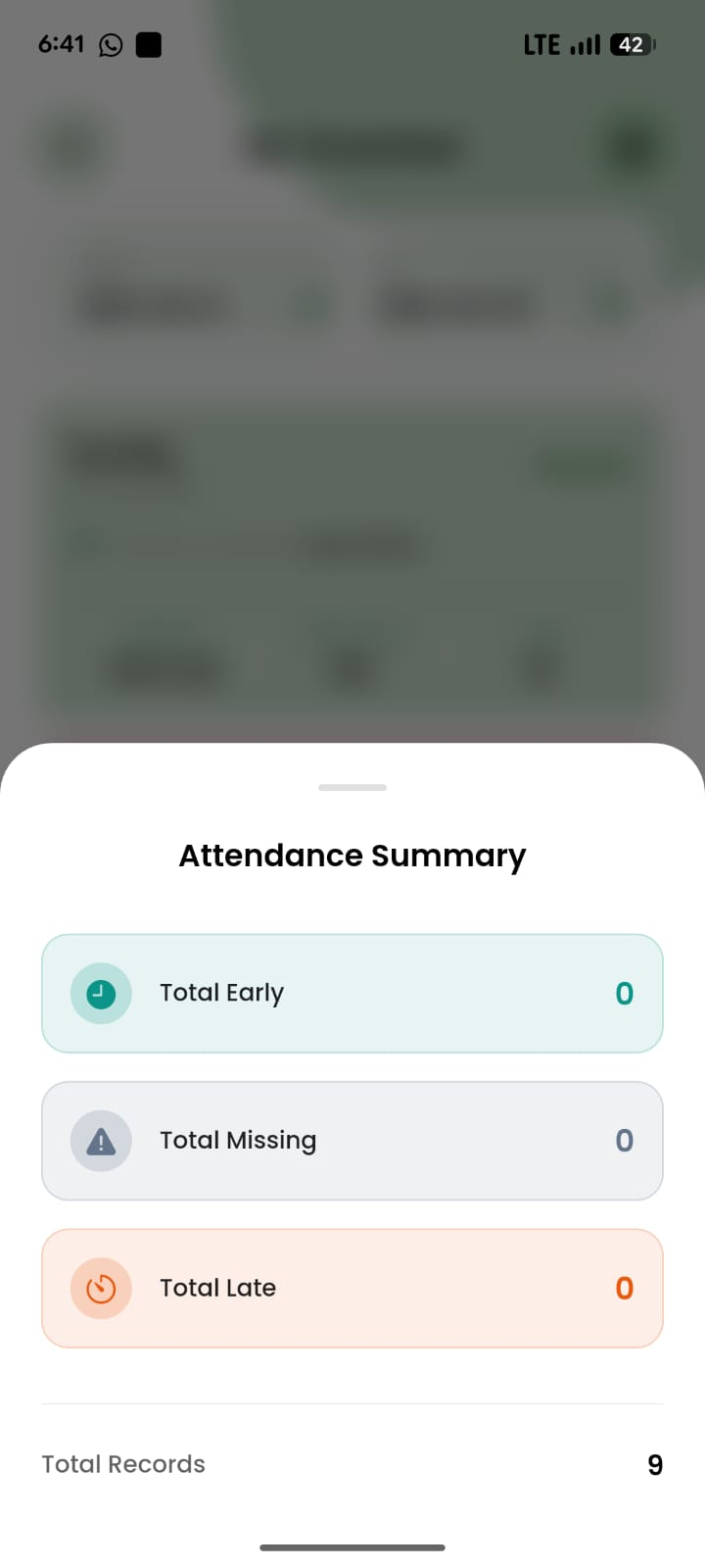
- Employee can view his attendance summary

- Leave Request

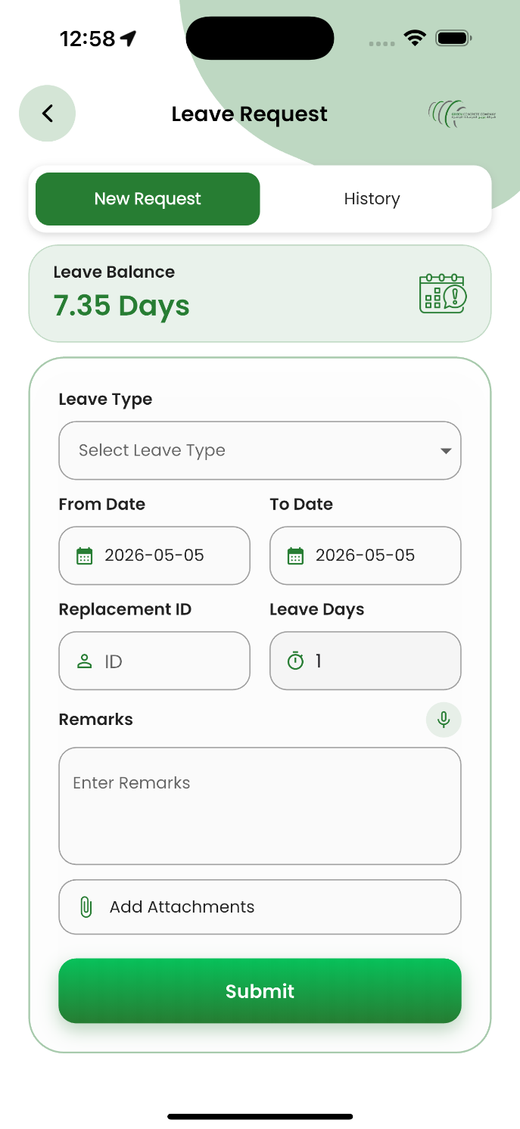
- Employee can add leave request.
- Once request type is selected, employee will add further remarks, from date, to date and replacement employee ID and submit this request.

Installation / Setup Guide

Steps to install and run the app:

Android APK: Download App
iOS App: Download App

Web Dashboard Panel

Following is the link to open the dashboard:
Web Panel: Open Dashboard

Approval

Approved by:
Signature: __________________
Name: _____________________
Date: ______________________

Approved by:
Signature: __________________
Name: _____________________
Date: ______________________

Approved by:
Signature: __________________
Name: _____________________
Date: ______________________

Approved by:
Signature: __________________
Name: _____________________
Date: ______________________

Approved by:
Signature: __________________
Name: _____________________
Date: ______________________

Approved by:
Signature: __________________
Name: _____________________
Date: ______________________

